**TestRail Tool Assessment**

# **Introduction**

# **Features**

# **Pros and Cons of Testrail over other tools**

# **Comparison with other tools**

# **Pricing**

# **1. Introduction**

# TestRail is a web-based test management tool used by testers , developers and other stakeholders to manage , track and organize software testing efforts. It follows a centralized test management concept that helps in easy communication and enables rapid development of tasks across the QA team and other stakeholders . TestRail is a test management tool which can be integrated with top applications like Jira, Cucumber, Selenium, and Bugzilla etc.TestRail is a web-based software which means you need not to install anything on your machine in order to efficiently manage, track and organize your test cases, test plans, and test runs. **2. Features 2.1. Integrations** TestRail supports a large number of add-ins which helps to connect with different software across the globe such as JIRA, Github,TFS, Visual Studio, Bamboo, Cucumber, Egg Plant, Jenkins, HipChat, Selenium etc. It also provides support for Rally and Version One integration. So when you use TestRail, you need not change your current framework, just get the add-ins and integrate your existing tools with TestRail.

# **2.2. Test Case Management** TestRail covers the complete testing life-cycle, from entering test cases, organizing them in test suites, assigning test runs to project milestones, running tests, capturing results, and generating reports. Project dashboards and email notifications keep you informed along the way. All activities and test results are archived so that you can reference them later and learn from past projects. **2.3. Reporting** TestRail’s dedicated reporting section makes it easy to generate comprehensive project reports, track the coverage of your tests, references, and defects, as well as many additional metrics and statistics.

All built-in report templates are highly configurable to adjust them for your needs and cover the scope you require.  
  
**2.4. Test Methodologies Support:**   
TestRail tool is capable of supporting different types of testing and associated methodologies. Agile Testing, Black Box Testing,Exploratory and Functional/Manual Testing.

**2.5 Email Notification Support**TestRail supports email notification. Users can subscribe to the email for a particular task by using voting and watching features in order to keep an eye on the task progress. We just need to use @mention in order to get the attention of a specific team member or stakeholder in Comments and Description fields. For example, if a developer needs more information about a test case then he can mention the name of the tester by using his @name and tester will be notified.

**3. Pros and Cons**Here, we are going to compare TestRail with other web-based management tools. They are SpiraTest and TestLodge.

**3.1 Licensing**:   
The commercial version of all these test management tools offer 30 days’ free trial version to get familiarized with these tools. The licensing agreement of SpiraTest and TestRail is based on the number of users. On the other hand, the licensing rules for TestLodge tools are based on the number of activities which include test cases, test plans, and test runs but not on the number of users.

**3.2 Access control**:  
 TestRail access control is very fine-grained where we can edit existing or pre-set roles, add new roles, and prepare user groups. Each role is associated with a set of permissions for milestones, test cases, test results, reports, configurations, and attachments. SpiraTest access control is very similar to that of TestRail. In TestLodge, you can edit pre-set roles and create custom roles but it also allows you to assign admin roles to a user which can define the set of permissions to other users for test cases, reports, test runs, test plans, and test suites.

**3.3 Working interface**:  
 Both TestRail and TestLodge test management tools have simple UI and they are very well organized in terms of ease of use and capturing the idea of the project under test. Such a working interface can be compared with SpiraTest where intuitive UI is offered by the SpiraTest tool that makes it capable to filter down the number of shells on the workspace. Such a feature also makes SpiraTest a tool difficult to work on due to the multiplicity of the “edit” and “update” buttons which confuses the user and makes the user make the redundant “clicks” and triggers edit and update operation which may cause problems.

**3.4 Requirement Management**:  
 TestRail does not support built-in Requirement Management (RM) service which is present in both TestLodge and SpiraTest test management tools. But TestRail can be integrated with equivalent external services such as Jira at no extra cost to contribute to requirement management where we can perform CRUD operations, attach document files, and assign test cases to the requirements. Therefore, it can also help in the preparation of traceability matrices.

**3.5 Test design**:  
  
 TestRail and TestLodge test management tools are capable to skip the typical process to perform CRUD operations on the test-cases and allows you to add a test case requiring bare minimum details such as title, steps, expected result and description.

**3.6 Test execution**:   
  
The test execution results in both TestRail and SpiraTest tools are displayed as a tree whereas TestLodge presents test results in the row mode as one by one on the main page. The tree structure is very simple to understand as it displays the values and the results more clearly than row mode result display. Also, the TestRail tool allows tracing the test launches history which is not very clear in SpiraTest tool.

TestRail provides a detailed user guide for reference. It is pretty easy to understand. They have explained it really well by using detailed screenshots. You can find the guide, training courses, and other valuable documents here:

<http://www.gurock.com/testrail/support/>

**4. Jira vs Testrail Comparison**

|  |  |  |
| --- | --- | --- |
| **Feature** | **TestRail** | **Jira** |
| Access Controls/Permissions | Yes | Yes |
| Collaboration Tools | Yes | Yes |
| Compatibility Testing | No | Yes |
| Debugging | No | Yes |
| Deployment Management | No | Hes |
| Reporting/Analytics | Yes | Yes |

**5. Pricing**  
TestRail provides14-free trial for new users and then you can choose from their different plans according to your project needs. You can find their pricing details here: <http://www.gurock.com/testrail/pricing/>  
  
**TestRail Professional Cloud Pricing**

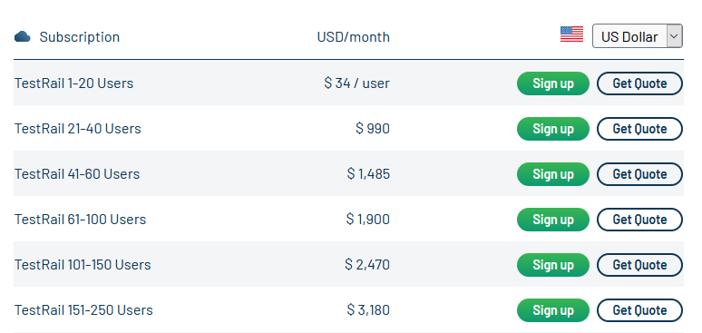

**TestRail Professional Server Pricing**